**PROGRAM**

**HOMEPAGE:**

<html>

<head>

<title> SATHYABAMA UNIVERSITY</title>

</head>

<body bgcolor="Black">

<center style="background-color:#fff8dc"><font style="Times New Roman" color="black"><br><h1><u>SATHYABAMA INSTITUTE OF SCIENCE AND TECHNOLOGY</u></font></h1>

<br>

</center>

<table width="100%" color="pink" BORDER="6" bordercolor="white">

<tr>

<th><a href="https://www.sathyabama.ac.in/about-us"><font color="yellow">About Us</font></a></th>

<th><a href="Timetable(39120109).html"><font color="yellow">Timetable</font></a></th>

<th><a href="school(39120109).html"><font color="yellow">Schools</font></a></th>

<th><a href="RESULT(39120109).html"><font color="yellow">Result</font></a></th>

</tr>

<img src="sathya.jpg" width="1518" height="555" align="center">

</body>

</html>

**TIMETABLE:**

<html>

<head>

<title>Timetable</title>

</head>

<body bgcolor="Cornsilk">

<center style="background-color:#A52A2A"><h1><font color="Cornsilk"><b>SATHYABAMA</b> </font></H1>

<h3 ><font color="Cornsilk"><b>INSTITUTE OF SCIENCE AND TECHNOLOGY</b></font></H3>

<H4><font color="Cornsilk"><b>(Deemed to be university) </b></font></H4>

<H2><font color="Cornsilk"><b> TIMETABLE</b></font></H2>

<br>

</CENTER>

<br>

<table width="750" height="400" cellpadding="7" align="center" border="10" bordercolor="Darkred">

<tr bgcolor="brown" ><td colspan="2" align="center"><font color="MistyRose">SEMESTER TIMETABLE</font></td></tr>

<tr><td bgcolor="brown" > <font color="MistyRose">MONDAY </font></td><td>OPERATING SYSTEM</td></tr>

<tr ><td bgcolor="brown" ><font color="MistyRose">TUESDAY</font></td><td>WIRELESS SENSOR NETWORKS AND ARCHITECTURE</td></tr>

<tr><td bgcolor="brown" ><font color="MistyRose">WEDNESDAY</font></td><td> CIDD </td></tr>

<tr><td bgcolor="brown" ><font color="MistyRose">THURSDAY</td></font><td>COMPUTER GRAPHICS AND MULTIMEDIA APPLICATIONS</td></tr>

<tr><td bgcolor="brown" ><font color="MistyRose">FRIDAY</font></td><td>FOG AND CLOUD COMPUTING</TD></TR>

<TR><TD bgcolor="brown" ><font color="MistyRose">SATURDAY</font></TD><TD>AR AND VR</TD></TR>

</BODY>

</HTML>

**FRAMES:**

<html>

<head>

<title>SCHOOLS</title>

</head>

<frameset rows="50%,50%" cols="50%,50%">

<frame src="first.html">

<frame src="second.html">

<frame src="law.html">

<frame src="mech.html">

</frameset>

</html>

1. **FRAME 1: (SCHOOLS)**

<html>

<head>

<title>School Of Computing </title>

</head>

<body bgcolor="FloralWhite">

<center><h1><font color="Brown" style="border:Black; border-width:10px; border-style:outset;"bgcolor="MistyRose">SCHOOL OF COMPUTING</font></h1></center>

<br>

<p>The School of Computing, Sathyabama Institute of Science and Technology welcomes you all. The School of Computing comprises of Department of Computer Science

and Engineering and Department of Information Technology. The Department of Computer Science and Engineering provides B.E.

Computer Science and Engineering with NBA accreditation, B.E. Computer Science and Engineering with specialization in Artificial Intelligence, B.E.

Computer Science and Engineering with specialization in Data Sciences, B.E. Computer Science and Engineering with specialization in IoT, M.E. Computer Science

and Engineering programmes. The Department of Information Technology provides B.Tech Information Technology.

The school also offers Ph.D. in Computer Science and Engineering, B.Sc. Computer Science, M.Sc. Computer Science and many certification courses.

</p>

</body>

</html>

1. **FRAME 2:**

<html>

<head>

<title>School Of Electrical And Electronics</title>

</head>

<body bgcolor="FloralWhite">

<center><h1><font color="Brown" style="border:black; border-width:10px; border-style:outset;">SCHOOL OF ELECTRICAL & ELECTRONICS </font></h1></center>

<br>

<p>School of Electrical and Electronics Engineering consistently and competently drives towards excellence through our departments of Electronics and Communication Engineering,

Electronics and Telecommunication Engineering, Electrical and Electronics Engineering and Electronics and Instrumentation Engineering.

With a strong emphasis on converting science to technology, the prime focus of our school is to impart quality education through hands on training, workshops and

research in the frontiers of Signal/Image Processing, VLSI Design, Power Electronics, Embedded systems, Wind Energy, Nanotechnology and Telecommunications.

</p>

</body>

</html>

1. **FRAME 3:**

<html>

<head>

<title>School Of Mechanical</title>

</head>

<body bgcolor="FloralWhite">

<center><h1><font color="Brown" style="border:black; border-width:10px; border-style:outset;">SCHOOL OF MECHANICAL </font></h1></center>

<br>

<p>It has been a privilege a look back of 30 years of Aeronautical, Automobile, Mechanical and Mechatronics when there is so much to feel proud of and

so much to celebrate. Past years have been extremely successful and satisfying in terms of accomplishments and accolades in scholastic, co-scholastic and

infrastructural development areas.</p>

</body>

</html>

1. **FRAME 4:**

<html>

<head>

<title>School Of Law </title>

</head>

<body bgcolor="FloralWhite">

<center><h1><font color="Brown" style="border:black; border-width:10px; border-style:outset;">SCHOOL OF LAW</font></h1></center>

<br>

<p>Legal education is at a pivotal moment right now and Sathyabama School of Law is evolving to address the society’s need by adding value to the

students learning to serve society and spirit of community is an integral part of our curriculum. Ever since its inception, School of Law has stood by

its strong dedications to the study of law and interdisciplinary approaches to law and the focus is on real-world skills required to be ready for practice.

School of Law is defined by its way Legal Education is imparted and the school is keen on investing for students’ intellectual and personal development.

School of Law functions with most dynamic leadership programs, events and initiatives that help students gain a deeper understanding of leadership and carry leadership qualities.

In the process, students grow as engaged leaders on campus, in the community, and beyond. School of Law is well known for its discipline, exposure and qualified faculty and

their commitment. < /p>

</body>

</html>

**FORM: (RESULTS)**

<html>

<head>

<title> RESULTS </title>

</head>

<body bgcolor="Cornsilk">

<center style="background-color:#000000"><h1><font color="Cornsilk"><b>SATHYABAMA</b> </font></H1>

<h3 ><font color="Cornsilk"><b>INSTITUTE OF SCIENCE AND TECHNOLOGY</b></font></H3>

<H4><font color="Cornsilk"><b>(Deemed to be university) </b></font></H4>

<H2><font color="Cornsilk"><b> END SEMESTER EXAMINATION RESULTS</b></font></H2>

<br>

</CENTER>

<br>

<br>

<br>

<br>

<form >

<CENTER><Label for="reg no"><h1><b>ENTER REGISTER NUMBER:</b></h1></label><br>

<input type="text" id="regno" name="regno"><br><br>

<Label for="dob"><h1><b>DATE OF BIRTH(dd/mm/yyyy):</b></h1></label><br>

<input type="text" id="dob" name="dob" maxlength="10"><br><br>

<input type="Submit" value="Submit">

</center>

</form>

</body>

</html>

**OUTPUT**

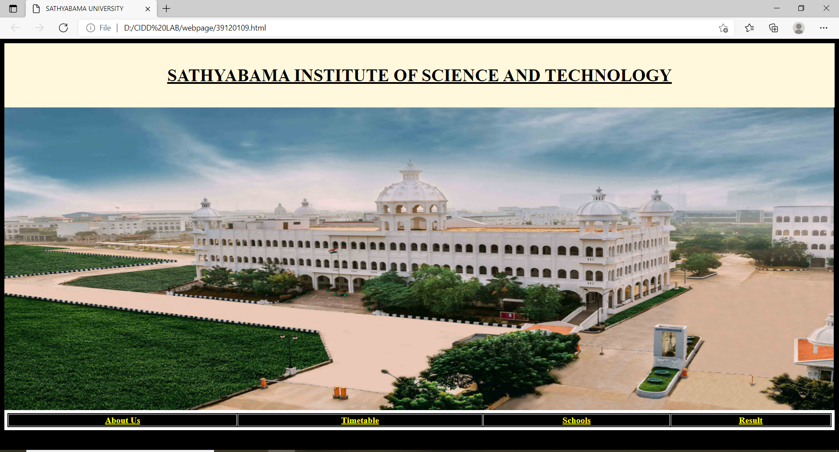

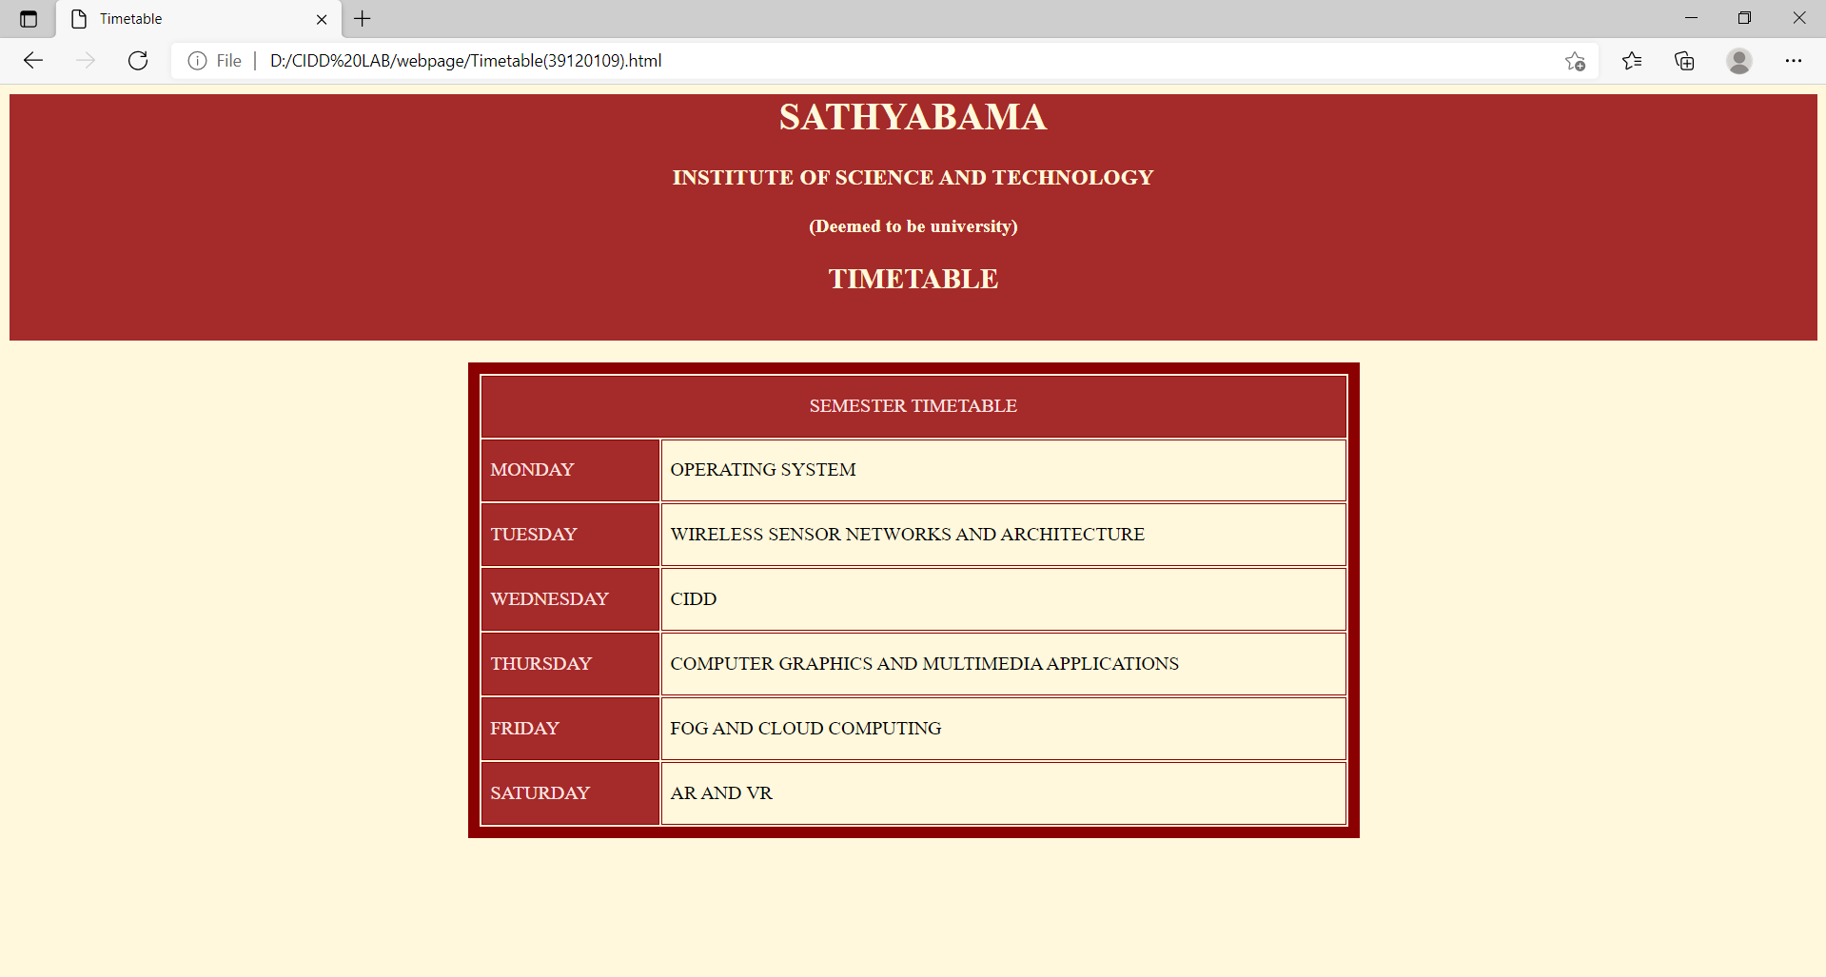

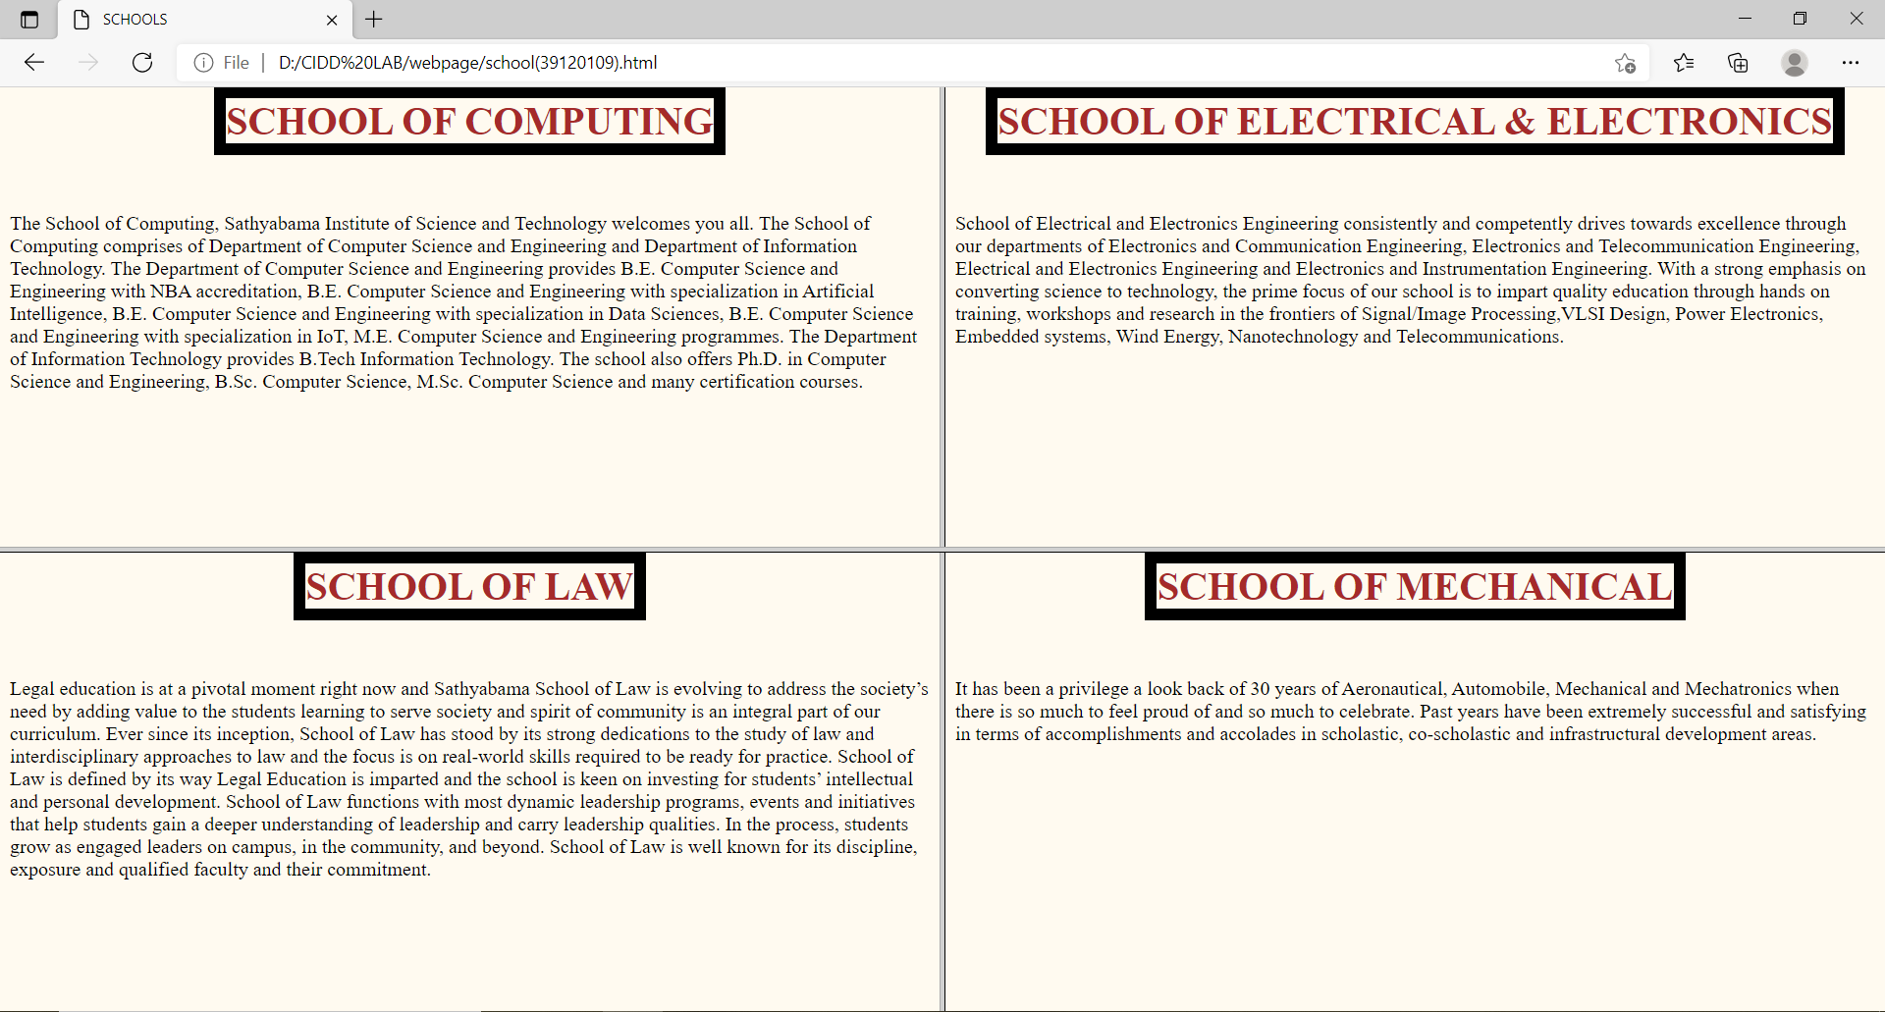

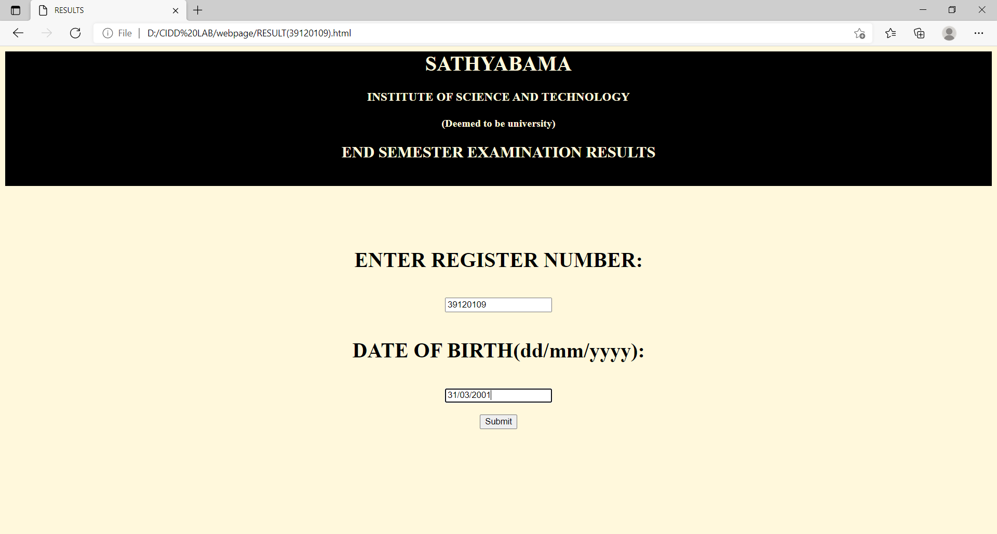

**(I HAVE LINKED THE SATHYABAMA WEBSITE IN “ABOUT US” IN THE HOMEPAGE)**

